Neosha Allen
Module 6.2 Assignment

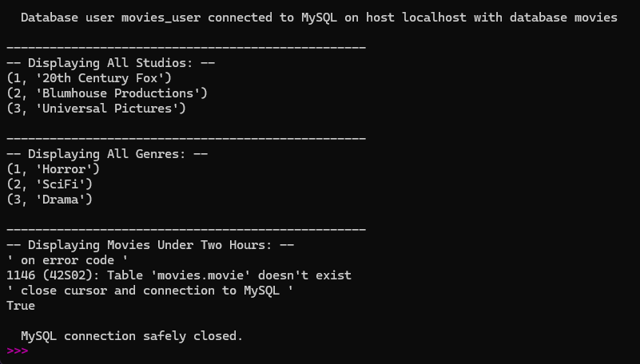
https://github.com/allenneosha/csd-310/tree/main/module-6

